**DayDreamer**

Huseyin Emre Sardogan

Parsons School of Design 10011, NY

sardh743@newschool.edu

**ABSTRACT**

In this paper I described the requirements for designing and building an Arduino (microcontroller) based DIY project inspired from a conceptual research.

**Author Keywords**

Concepts: Day dreaming, lighting, reflection, vibration, colors, feelings.

Methods: Coding (Arduino IDE), AutoCAD, Photoshop, woodworking, soldering.

Materials: Wood, tracing paper, transparent paper, Mylar, aluminum foil, headphones, vibrating motors, NeoPixel Rings, Bluetooth Shield, Gesture Sensor, Android Smartphone.

**CONCEPT STATEMENT**

Daydreamer is a product, which, is built to serve the purpose of creating fake atmospheres rooting from the relationship of color and human psychology. The inspiration beneath the idea is my observations on a humanitarian urge of dreaming and creating your own realty. After a valid amount of research and experimentation I was capable of building a circuit, which shines up in 4 different color schemes, with voice commands. The experience is powered up by usage of vibration transferring motor attached to a facial bone.

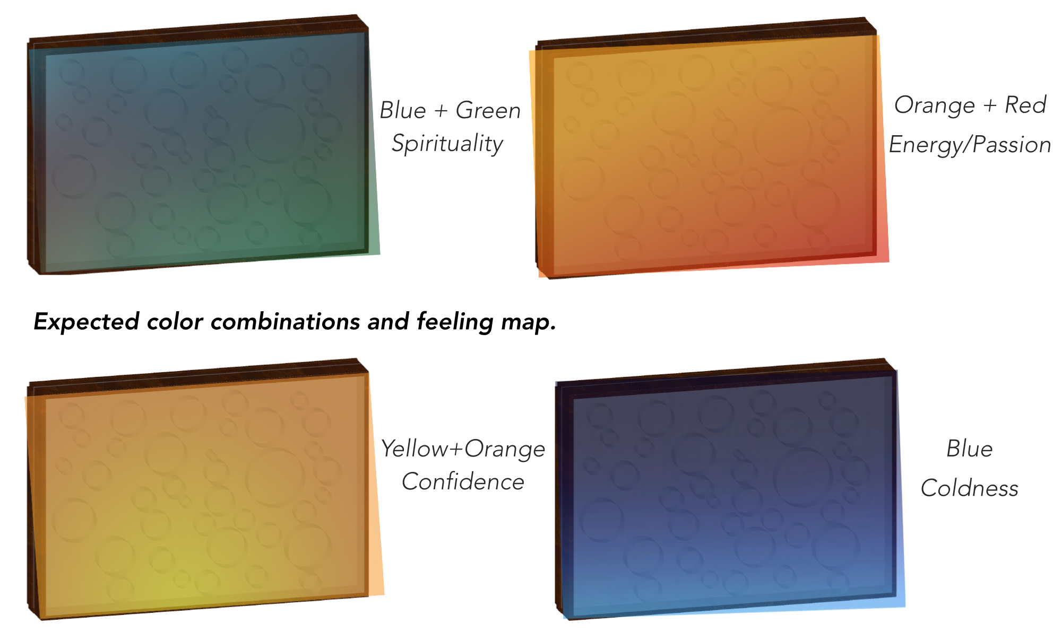

Figure .LightBox Effects.

**Abstract and Keywords**

Concepts: The purpose of building this product was to imitate natural atmospheres with lighting (figure 1)in order increase the efficiency of the daydreams by psychological effect of colors. Expected outcome from the

product was to; successfully paint the room with colorful lighting by getting additional reflection from Mylar, also by sending vibrations of music to facial bones in order to create an in between state. Through the progress of my research, I decided to use color schemes of natural moments such as, blue-green-magenta representing spirituality, colors of aurora lights. Moreover, through my progress, I decided to use vibrating motors, because I want sound to be natural which is not heard by ears but just vibrations through the closest bones of your nerve system. The key to create an artificial state is manipulation of human senses.

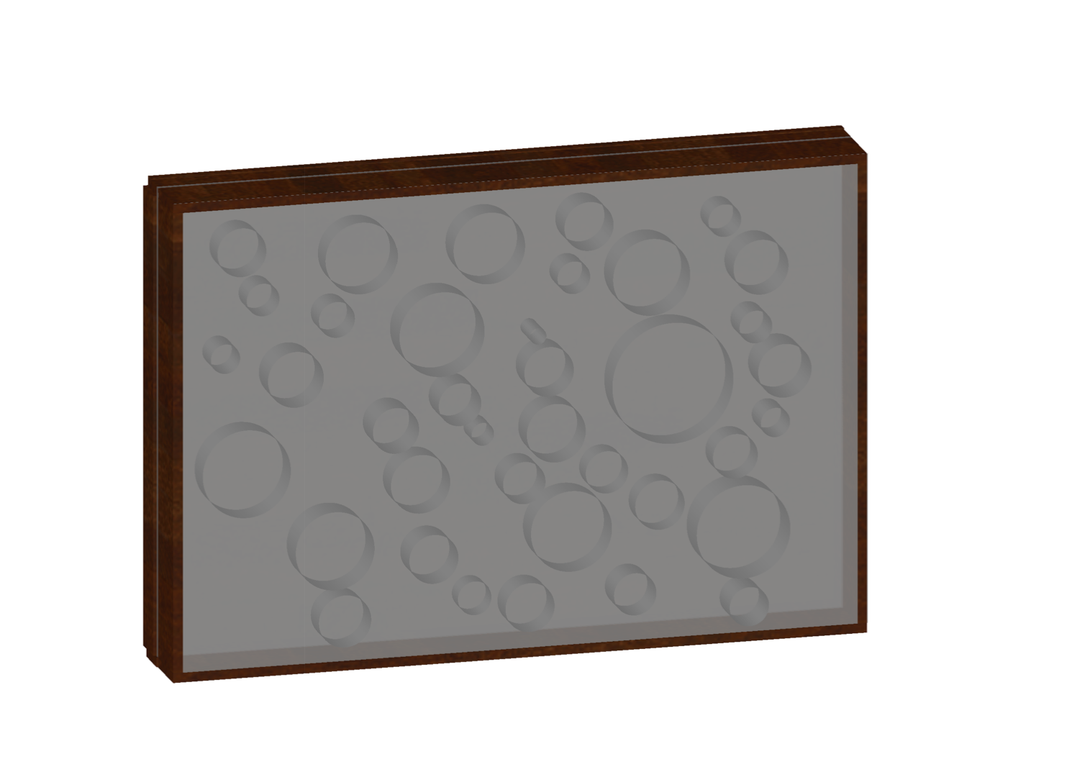

Figure 2. AutoCAD.

Methods: Prototyping digitally made on AutoCAD (Figure 2). and the possible visual outcome combined on Photoshop (x). Coding of the lights and connection is made on Arduino IDE. The connection between the user and the artifact has created by using an application existing on Google Play store. The physical object is done by wiring, woodworking and lumber for easy cuts. Also soldering is used in order to merge the cables.

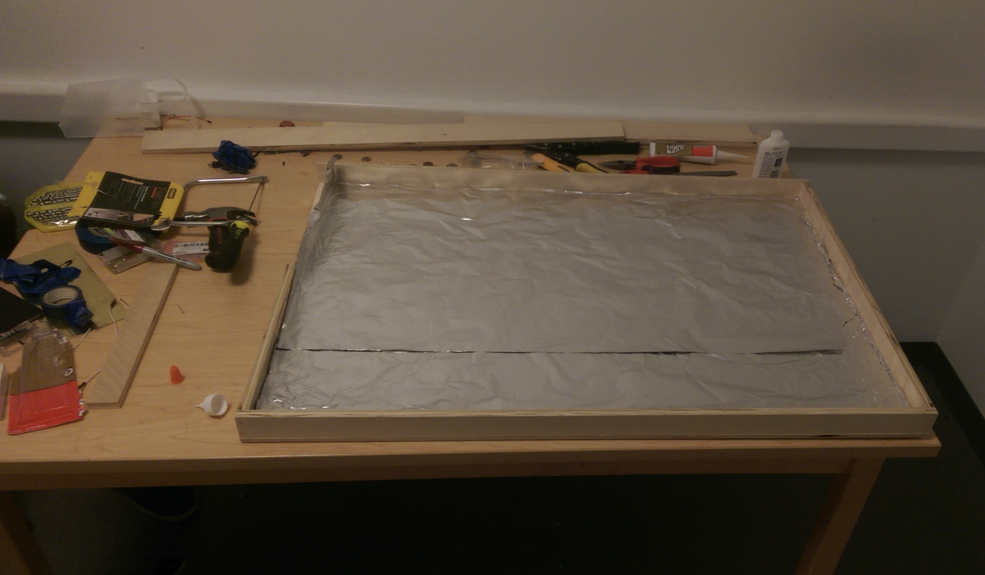

Figure 3. Artifact.

Materials: Since I wanted to create and artificial but an organic state, I wanted to use a material from nature, so I built the light box mostly out of Canadian Plywood and a piece of Chinese Plywood. For light to leave the box front side is covered by tracing paper. In addition the inside is covered with mylar in order create extra reflection and increase the amount of light NeoPixel creating (Figure 3.) The technology pieces inside are mostly for lighting and voice command connection. The gesture sensor can be intractable when the user approach to it. Voice command connection, includes turn on/off, standby, and different single word commands for mood transition. Gesture sensor includes turn on/off commands and two color effects from the official library by Ada Fruit industries.

**APPLICATION AND FUNCTIONALITY**

The technology of the product has total functionality, however the design is not a fully finished version. Current end product is capable of answering 7 different commands from Bluetooth and Android connection. The NeoPixels located inside the light box are also responsive to 4 different commands coming through the readings of Gesture Sensor. In addition, the vibration motor is also functional, however, during the time of experimentation, one side of the headphone has damaged and stop working. The product can be used in a standing position wherever in any room. By creating total darkness and silence user can seize the maximized experience.

**CONCLUSION**

The main intention of the project was experiencing daydreams by manipulating the nervous system.

Artifact achieves the goal of creating artificial reality, by using organic materials, translucent design, lighting under psychological circumstances and sound directly vibrational to skull.

Daydreamer is a final working prototype for a research, which was based on development of daydreaming by using psychological effects of color and experimental methods of vibration usage for an unexpected feeling. (figure 4)

**ACKNOWLEDGMENT**

I would like to thank Michael Wolf and Ayodamola Okunseinde for their guidance and instructions. Also I would love to thank Midtown Lumber of NYC for technical help on building the artifact.

**REFERENCES**

1.Color Research;

<http://www.colour-affects.co.uk/research>

<http://www.empower-yourself-with-color-psychology.com>

2.Daydream Meaning;

[www.thefreedictionary.com/daydream](http://www.thefreedictionary.com/daydream)

3.Daydream Research;

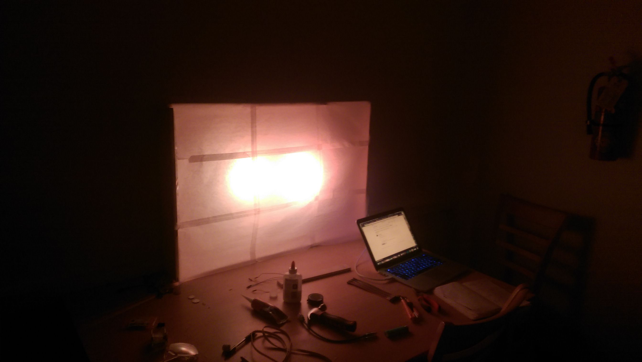<https://www.sciencedaily.com/releases/2009/05/090511180702.htm>

<http://worklife.wharton.upenn.edu/2015/09/daydream-get-job-done-josh-davis/>

Figure . Artifact in use.